**Chapter 6: Bandwidth Utilization – Multiplexing and Spreading**

Table of Contents

6.1 Multiplexing 3

Frequency-Division Multiplexing 4

Wavelength-Division Multiplexing 7

Time-Division Multiplexing 8

6.2 Spread Spectrum 12

Frequency Hopping Spread Spectrum 12

Direct Sequence Spread Spectrum 14

Bandwidth utilization refers to the efficient use of available bandwidth to achieve specific goals. This is done through multiplexing. Other goals like privacy and anti-jamming can be achieved through spreading.

## 6.1 Multiplexing

When the bandwidth of a medium linking two devices is more than the bandwidth required by the devices, the link can be shared. This allows simultaneous transmission of multiple signals across a single data link. The process is done using a set of techniques and is known as multiplexing. For example, an operator could combine the links with individual subscribers so that they have a larger total bandwidth.

Multiplexing a part of the physical layer, since it deals with how the physical link between devices is to be used. Be careful not to confuse it with multiple access, which is a technique used in the data link layer.



In the process of multiplexing, input lines are divided into channels inside a single link. On the other end of the link, a demultiplexer is used to divided the output back into the output lines.

A channel refers to the portion of a link that carries data between a specific pair of input and output lines. The main concern now is how the input lines are divided into channels. There are three techniques to do this:

* Frequency-division multiplexing, used with analogue signals
* Wavelength-division multiplexing, used with analogue signals
* Time-division multiplexing, used with digital signals

### Frequency-Division Multiplexing

As the name suggests, in FDM, input lines are divided into channels based on frequency. Each input thus gets a fraction of the total link, but the point to keep in mind here is that they are able to use it continuously. This is in stark contrast to time-division multiplexing.

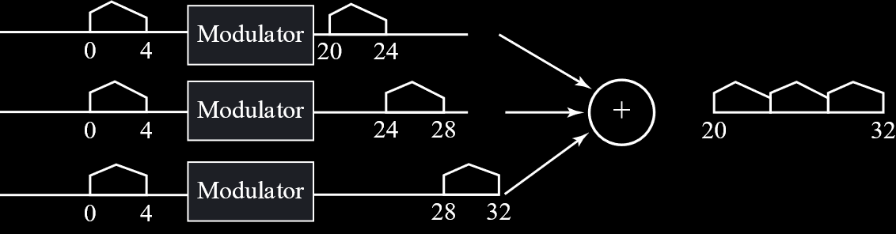

For example, in the diagram above, each of the three users are using a bandwidth. The multiplexer uses analogue-to-analogue modulation to place each of those inputs onto a band, from to for the first user, from to for the second user and from to for the third user. Thus, the total bandwidth of the line is from to .

To get a clearer picture of how this process works, we can consider the time domain instead of the frequency domain.



On the other end, band-pass filters are used to divide the combined signal back.



The first filter only allows signals from to , meaning only the corresponding part of the combined signal will be sent to the first user. The same process is used elsewhere.

On the time domain, it looks like this:



Often, there will be guard bands between the different channels. For example, two channels could have a guard band between them which neither is allowed to use. This is for security purposes.



Example

Say we have a satellite channel of and four data channels that each need to be transmitting data at .

We need to divide the satellite channel into four parts, so each part only gets . Since the data rate of a channel must be maintained at , we need to transmit bits per . Essentially, this means each signal element must be capable of transmitting bits. One possible modulation technique that can achieve this is 16-QAM.

Example

One of the standards used for mobile telecommunication is Advanced Mobile Phone System (AMPS). This uses an uplink for sending data and a downlink for receiving data.

Say the uplink is a band from to and the downlink is a band from to . Each user requires in either direction. We need to find the theoretical limit to the number of users that can share an uplink or a downlink.

Since each band is , there can be users simultaneously. In reality, channels are used of which are kept as control channels.

#### Analogue Hierarchy

Telephone companies traditionally use a hierarchy system in which FDM is used to combine voice channels into a group, such groups are combined to a super group, super groups are combined to a master group and master groups are combined to a jumbo group.



### Wavelength-Division Multiplexing

Wavelength-division multiplexing is similar to frequency-division multiplexing and is used with fibre optic cables, thus involving light signals. Essentially, the input signals are divided based on their wavelength. The actual multiplexing and demultiplexing process takes place using prisms. We will not be covering WDM in detail.

### Time-Division Multiplexing

For TDM, instead of dividing the channel into parts, each user is given the entire bandwidth, but for a specific amount of time. Thus, each user sends just a fraction of data in each time slot. Time is divided in a round-robin fashion.

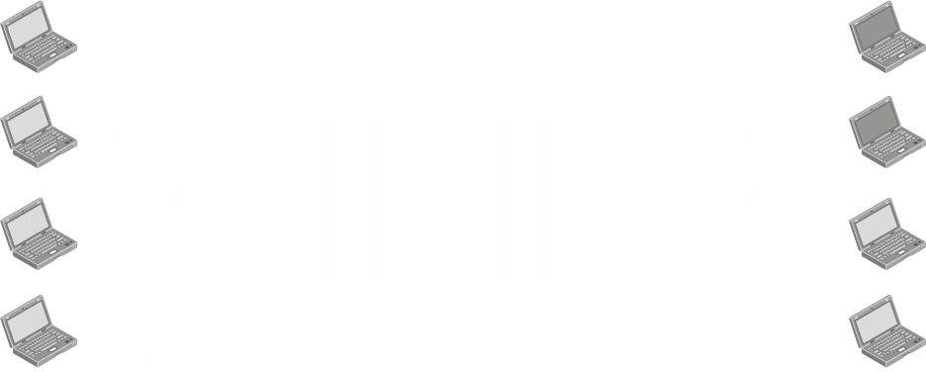

TDM has two variations, Synchronous TDM and Statistical TDM.

#### Synchronous TDM



In synchronous TDM, the sender and receiver ends are synchronized. Say data is being sent as frames, each with time . Thus, each of the three users in the diagram above will get a time slot on that frame. The first slot of each frame will be from the first user, the second slot from the second user and so on. Since we know this for certain, we can synchronize the receiver end so that the first slot of each frame is sent to the first receiver, the second slot to the second receiver and so on. This process is called interleaving. The complexity of the circuitry involved in interleaving will be much less due to the synchronizing capabilities.

Notice that the main link has a data rate that is times greater than the data rates of the individual inputs, which causes the unit duration to be times shorter.

A problem with synchronous TDM is that sometimes, bandwidth space may be wasted. For example, if the first user does not have any data to send with a particular frame, the first slot of that frame will remain empty.

#### Statistical TDM

To avoid the problem of inefficiency, we could ensure that only the inputs that actually have data are given space on the frames. However, if we do this, we need an addressing technique that would allow us to identify which sender is sending data to which receiver. This is the technique used in statistical TDM.

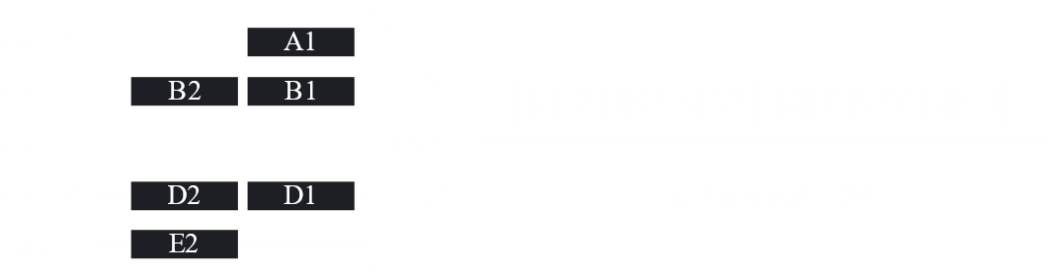

#### Data Rate Management

For synchronous TDM, sometimes, not all of the inputs have the same data rate. This disparity can be handled using three techniques:

* Multi-level Multiplexing
* Multiple-Slot Allocation
* Pulse Stuffing

Multi-level multiplexing is used when the data rate of an input line is a multiple of the data rates of the others. Say we have two links of while all the rest are of . Then, we can have one level of multiplexing for the first two links, which would result in an output of . This output can then be multiplexed with the other lines in another level of multiplexing.



Multiple-slot allocation is used when it is more efficient to divide a single input into smaller parts. For example, a input could be divided into two lines using a demultiplexer, essentially giving that input two slots in the final frame. Then it can be multiplexed with the other inputs normally.



Pulse stuffing is used when the inputs are not multiples of each other. Dummy bits are added to smaller inputs to give it the same data rate as the largest data rate input. Pulse stuffing is also called bit padding or bit stuffing.



#### Digital Hierarchy

A hierarchy technique like that for FDM is also available for TDM.



Here, instead of groups, the groups are called services.

## 6.2 Spread Spectrum

With spread spectrum, our goal is to prevent eavesdropping and jamming. Even though we have a limited bandwidth available to us, we will be using more than what we require for this purpose. Instead of say the actual we need, we will be using say .

Spread spectrum has two techniques, frequency hopping spread spectrum (FHSS) and direct sequence spread spectrum (DSSS).

### Frequency Hopping Spread Spectrum

In FHSS, we change the carrier frequency at regular time intervals. A pseudorandom code generator generates some code, and using that code, a frequency is selected from a table of frequencies that has been agreed upon by the sender and receiver. The selected frequency is used to modulate the original signal before transmitting it.

The advantage of this process is that if an attacker is tuned into one of the carrier frequencies, they will only be able to retrieve a part of the data being transmitted, not all of it.



They key here is that a pseudorandom generator is used. Essentially, this means the values are not completely random, but based on a value called the seed value. The sender and receiver are both aware of this seed value, which means that the same ‘random’ numbers are generated on both ends. This is how the receiver knows which frequencies to use at what time period.

Obviously, if we repeatedly use the same pattern of frequencies, eventually the attacker will figure out what the pattern is and will be able to change frequencies with us. This is not our concern at the moment.

Consider the figure below. It shows how the data is being sent using FHSS.

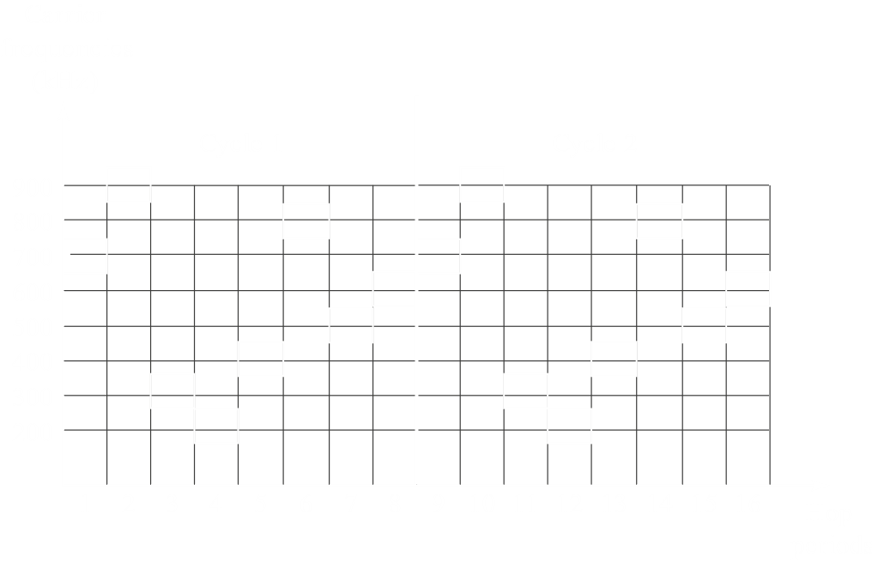

Clearly, we are wasting a huge amount of bandwidth. During the first hop cycle for example, only the frequency is being used while the rest remains idle. Instead, we could use the available bandwidth in a smarter manner, our work would be more efficient.

Similar to the concept of frequency division multiplexing, we could allow other users to utilize the unused portions of the bandwidth. If we do a good job dividing, then we can ensure there is no empty space left.



### Direct Sequence Spread Spectrum

In DSSS, each bit is swapped out for a spreading code called a Berker sequence, . For a bit, the spread signal represents this code, and for a bit, the spread signal is the complement of this code.



This method allows us to bypass jammers. Jammers are expecting bit of data, but instead we are sending bits. Thus, even if bit gets jammed, the other bits go through fine.